View on a mobile device.
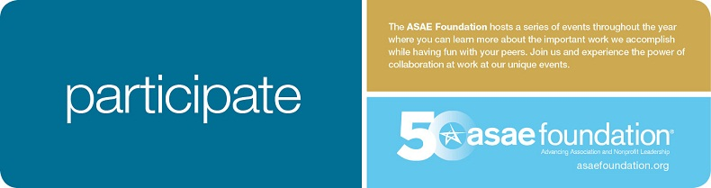
Andy Doyle, Susan Neely, Joe McGuire and John Graham
Along with
Steve Calderia, Matt Jenneret, Robert Weidner III and Susan Robertson
Cordially invite you to a reception and an evening connecting with old friends
to learn more about the mission and vision of the
Thursday, Februray 20, 2014
5:30 -7:30 p.m.
at
American Coatings Association
1500 Rhode Island Avenue NW
Washington, DC 20005
RSVP Required: ASAEFoundation@ASAECenter.org
202-626-2893
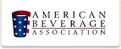
This invitation is exclusively for you.
.

