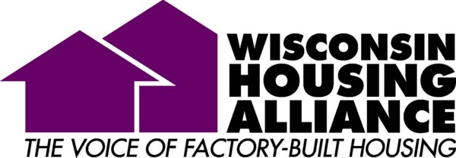

Communications and Information Technology Manager
Wisconsin Housing Alliance (WHA) is the trade association for the manufactured and modular housing industry in Wisconsin. This is a very small work environment where your work will be diverse. With a staff of three, you will get the opportunity to wear many hats and perfect many skills. This position offers opportunities to learn new job functions as you gradually take on additional key roles within the organization. In addition to the Wisconsin Housing Alliance, we run a non-profit charity called Tomorrow’s Home Foundation. This charity provides critical housing grants for low income families throughout Wisconsin. You will be an integral part of this critical housing program as well.
Our mission: To be an advocate for members, facilitating relationships which educate, support and promote the factory-built housing industry.
The Communications/IT Manager will be responsible for the development, oversight, and execution of WHA’s internal and external communication strategy and implementation. This includes all forms of communication including newsletter design, membership communications, website and social media presence, and more. The Communications/IT Manager will also be tasked with coordinating public relations efforts with the industry’s national association, the Manufactured Housing Institute (MHI).
POSITION RESPONSIBILITIES: (Full-time position)
Development, oversight and execution of an integrated communication strategy that utilizes the numerous sources of content generated by WHA activities.
- Development and oversight of WHA traditional and new media communication strategy, including social media and web based platforms.
- Development and management of resource materials and brochures promoting membership, meetings and events. This may include promoting the industry at trade shows or home shows. The ideal candidate will have the ability to speak in front of groups to communicate the industry’s message clearly.
- Oversee the formatting and content of the WHA newsletters and informational content. This includes tracking of readership for on-line publications and website usage.
- Various functions that may be added to this position include; grant writing, grant approval, fundraising and accounting.
- Ancillary duties may include answering/routing telephone calls, responding to member requests, project management, event registrations, event material compilation, mailings, filing and additional duties as needed.

AMOUNT OF TRAVEL REQUIRED: Travel within Wisconsin may be required for industry events 5-9 times per year. One to two overnight stays might also be required depending on event location. Reimbursement at the IRS mileage rate is provided for approved events.
EDUCATION REQUIRED: A minimum of an Associate Degree is required, Bachelor’s degree preferred or equivalent experience. Proficiency in MS Word, Excel, Publisher and website design software is also preferred. A successful candidate will be proficient with information technology. Education or experience in accounting, fundraising, website development/maintenance or grant activities would be advantageous.
Skills: Education or experience in an office environment, excellent oral and written communication skills, and strong proofreading skills.
- Education or experience in creating and managing an online and social media plan as part of an integrated communication strategy.
- Education or experience working with Google Analytics, content management systems, and HTML coding.
- Having a “TEAM” work ethic where everyone works together for the good of the industry is critical.
- Being able to multi-task and serve members with a can-do attitude.
- A desire to learn new functions and have a diverse skill set is essential.

Salary and health insurance reimbursement will be negotiated based on education and experience. We offer a flexible work schedule, long-term disability insurance, life insurance, a SIMPLE IRA retirement plan and a generous vacation and paid holiday schedule of time off.

To apply:
Send resume and cover letter to:

Amy Bliss
WI Housing Alliance
258 Corporate Drive, Suite 200C
Madison, WI 53714

Or email to: amy@housingalliance.us

Applications will be accepted from now until June 10th. Interviews will be held June 22-26 and July 7-10.
Start date will be flexible sometime between mid-summer to early fall, 2015.

Web site address: www.housingalliance.us

